Discovering Elston

The Story of a Deserted Medieval Village

In the Heart of the Sydling Valley

Thursday 3rd July 7.30pm

Sydling Village Hall

Doors and bar open from 7pm

Admission free

Proceeds of the bar to Sydling Historical Society

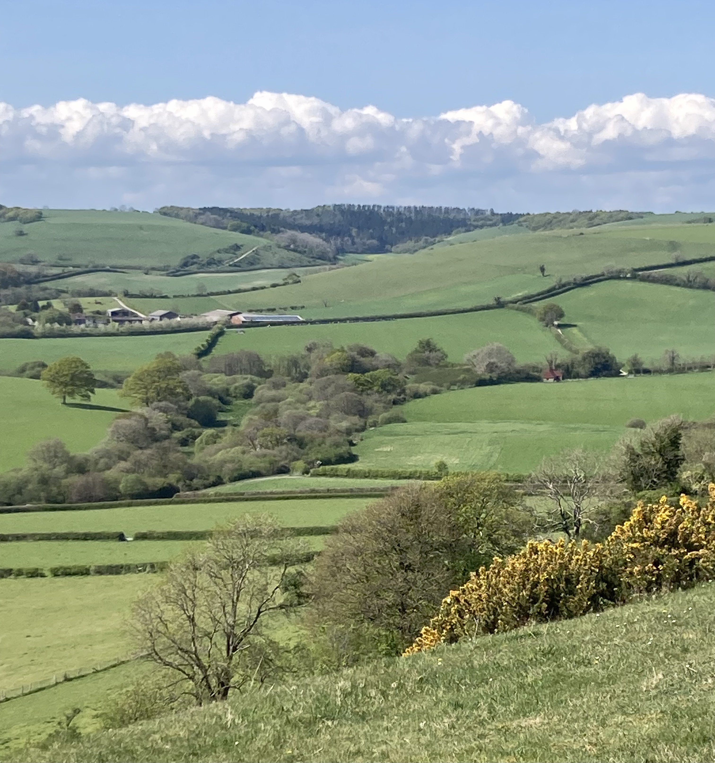

Elston, once a thriving a medieval hamlet nestled in the picturesque Sydling valley, now lies deserted, its story lost to history. Anne Brown explores the village's origins, its life during the medieval period, and the reasons behind its abandonment.